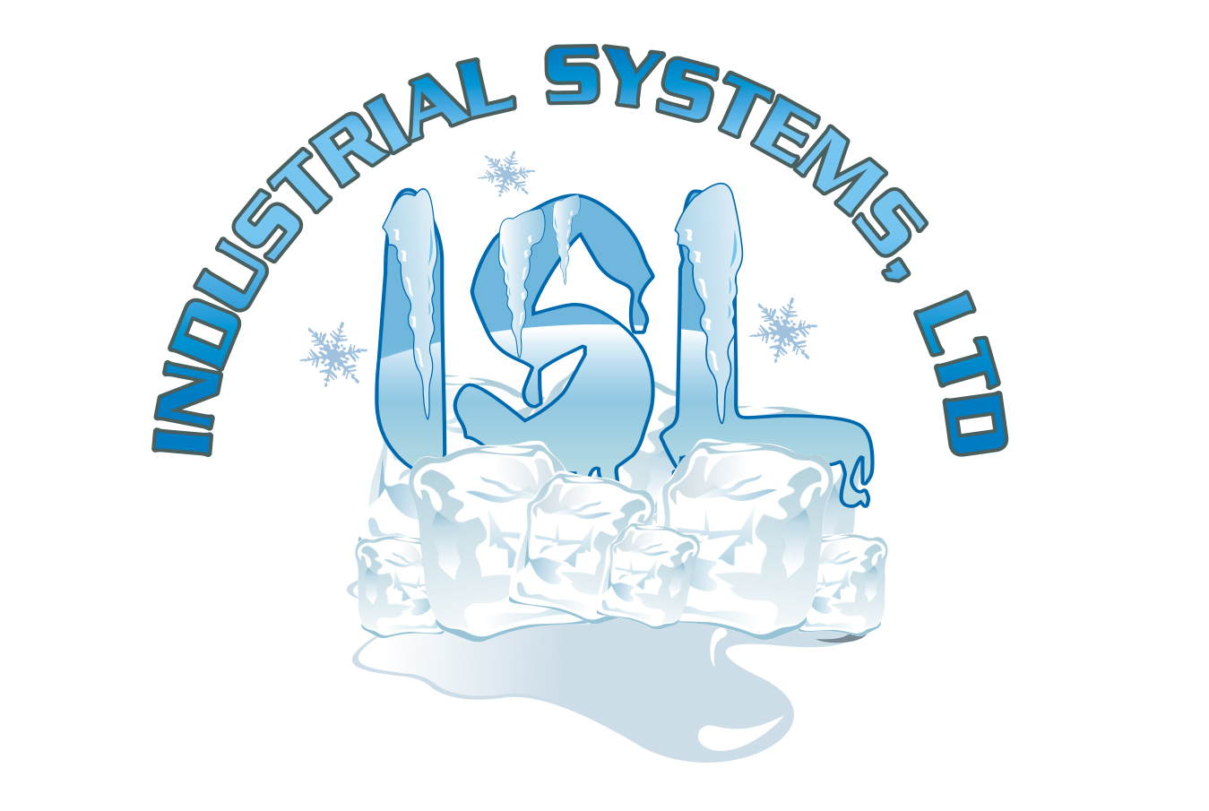
ThermaPoint Organic Polymer Based Anti-Icing & De-Icing Liquid

PRODUCT DESCRIPTION
ThermaPoint is an environmentally friendly product that will significantly and economically enhance your snow & ice management program. It is a natural agricultural product that is far more biologically stable than other organics so it doesn’t break down in your tanks. It is very effective in reducing corrosion when mixed with Sodium and or Calcium Chlorides. All ThermaPoint products are tested to be greater than 90% less corrosive than rock salt and meet PNS specifications. Its chemical description is an “Organic Polymer” whose long molecular chains make the product viscous enough to provide the longest lasting residual effect in the industry and yet fluid enough to apply to the road in the winter.

ThermaPoint is available in 4 versions:
ThermaPoint C - Is a super Concentrated Organic for customers with formulation blending operations. Because it measurably provides the longest lasting residual effect of all organics on the market, lower dosages are needed to make “Supermix” style products. Freeze point -27°F.
ThermaPoint S – Our Standard Organic concentrate is used to make “Supermix” formulations. In addition it is ideal for stockpile treating since its higher viscosity will resist running through the pile. The pile also stays pliable from one season to the next. Freeze point -29°F.
ThermaPoint AP – A premium All Purpose Organic product that is blended with enough Sodium & Calcium Chloride so that it is actually thick enough for stockpiles used within 1 season & fluid enough to be sprayed on roads for anti-icing. It is an excellent alternative to straight Calcium Chloride for pre-wetting rock salt. This is our most popular product! The residual effect on the road is fantastic. Freeze point -32°F.
ThermaPoint R – An economical Road ready Organic product blended with Sodium & Calcium Chloride that will perform nicely for all your
pre-wetting, anti-icing & de-icing applications. The residual effect will help prevent product runoff. Freeze point -41°F.

APPLICATIONS
Pre-wetting – Application rate is 3 -12 gallons per ton of rock salt at the spinner or onto loader bucket when loading truck.
- Melting begins immediately - no waiting for salt to make its own brine. Acts as a liquid accelerator for salt.
- Proven 30% - 40% reduction in salt use due to residual effect of organic and less bounce & scatter.
- 90% + lower corrosion rate than plain rock salt or brines.
- Use either ThermaPoint AP or R.
Anti-icing – Application rate for anti-icing is 20-30 gallons per lane mile. For frost prevention, use 15-20 gallons per lane mile.
- Prevents bonding of snow and ice to pavement.
- Prevents “black ice”.
- Has significant residual effect.
- Quick and easy application using spray rig with solid stream nozzles.
- Follow “Anti-Icing Application Decision Flowchart” for more detailed application information. Consult an ISL rep for a copy.
- Use ThermaPoint AP or R.
De-icing – Application rate is 40 gallons per lane mile.
- Melting begins immediately. ThermaPoint melts through up to ½” of dry packed snow to the pavement, using straight stream nozzles, where it will spread and break the bond between the ice & snow and the road allowing plows to remove it easily.
- Use ThermaPoint AP or R.

PHYSICAL PROPERTIES
Appearance/Odor: Dark brown liquid w/ mild odor § Weight: 10.3 – 10.7 lbs/gal depending on product
pH: 4.0 – 4.6 § Specific Gravity: 1.25 – 1.285 depending on product
Freeze Point: ThermaPoint C: -27°F | ThermaPoint S: -29°F; | ThermaPoint AP: -32°F; | ThermaPoint R: -41°F.

Industrial Systems Ltd. ▪ 112 W. Rt. 120 ▪ Lakemoor IL 60051 ▪ P: 815-344-5566 ▪ F: 815-344-5588 ▪ www.Ice-Melt-Products.com

